**Key Features**

Type-C

Form Factor

USB 3.1

Interface

300MB/s Seq. reads

64GB

Capacity

• USB Type C Drive has transfer speeds up to 4GB in as little as 15 seconds.  
  
• Multi-proof protection against water, shock, magnet, temperature and X-ray.

Storage

**64GB**

$13.99

**128GB**

$17.99- Current Price$20.99- original price

**Save $3.00**

**256GB**

$26.99- Current Price$34.99- original price

**Save $8.00**

**512GB**

$54.99- Current Price$64.99- original price

**Save $10.00**

**VIP Advantage**

**VIP Advantage membershipLearn more**

* 2 Year Samsung Care+ (without Theft and Loss)
* Exclusive Discounts & Early Access

To select this option, please sign in or create a Samsung account

**Premium Benefits**

**$149.99/yr**

**Delivery & professional services**

Availability for:

10001

Delivery

**Delivery**

Not available

**Choose your purchase option**

Questions? Ask a Financing Expert

**One-time Payment**

**$13.99**

**Pay in 4 Installments**

**$3.50**

**every two weeks σπ**

**One-time payment**

Pay with your credit card, debit card or a pay app. Excludes taxes and shipping.

**USB Type-C™ Flash Drive 64GB (MUF-64DA/AM)$13.99**

**Total**

**$13.99**



**Log in now to earn up to 1.5% back in Samsung Rewards Points**

**Add to cart**

[**Where to buy**](https://www.samsung.com/us/computing/memory-storage/usb-flash-drives/usb-type-c-64gb-muf-64da-am-buy)

Supported payment types:

adyen_cardsPayPal Venmo Checkoutamazonpaygooglepay

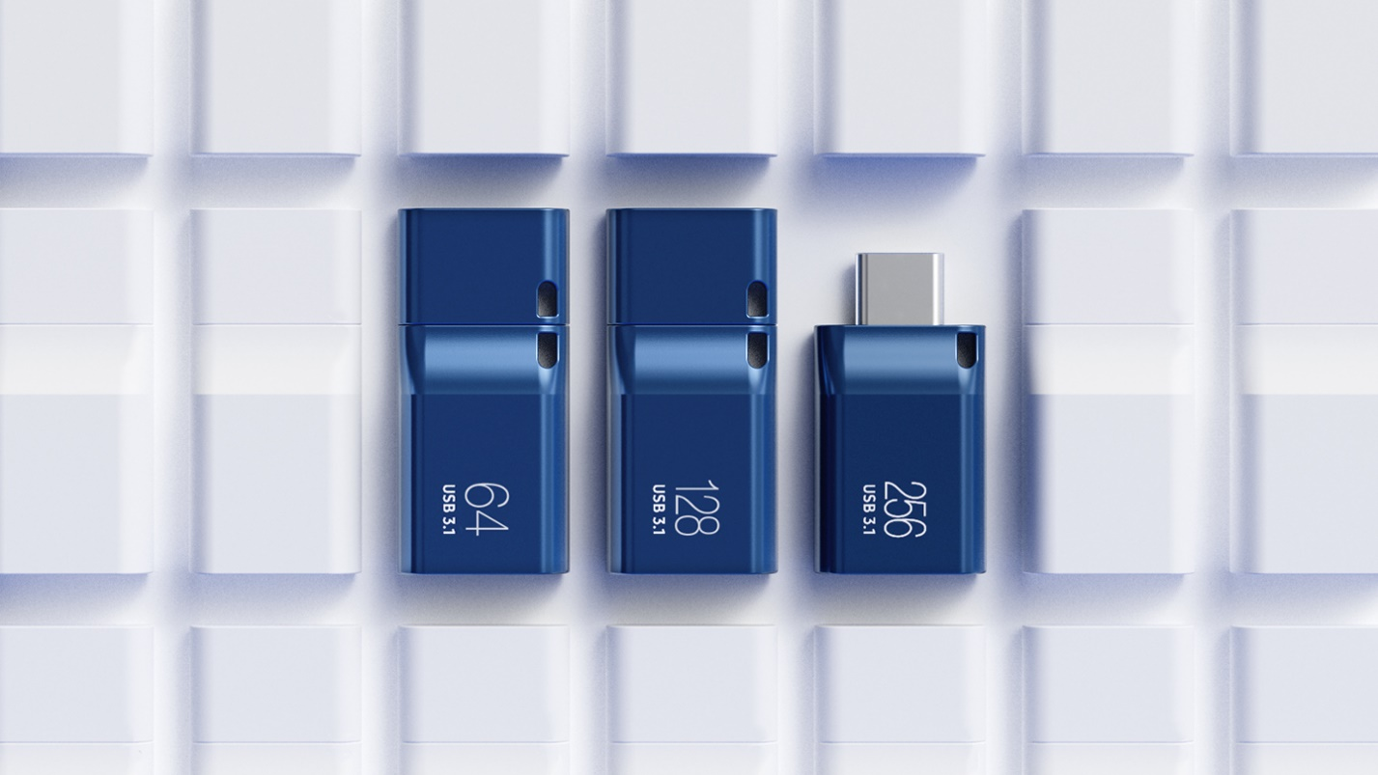

**USB-C storage  
on the go**

This sleek drive is supported by Samsung NAND flash, and is incredibly compact to fit in the palm of your hand. Count on reliable performance and fast transfer speeds while staying compact.

